**Title of the Project:**  
**Eco-Domes: Sustainable Living Pods for Urban Wildlife**

**Name:** **Ajith Shaik**

**GitHub URL:** <https://github.com/Ajithshaik/DB-3.git>

**SQL environment:**  
**Windows**

**ERD Model PART 3**

ERD using UML (**Physical Model):**

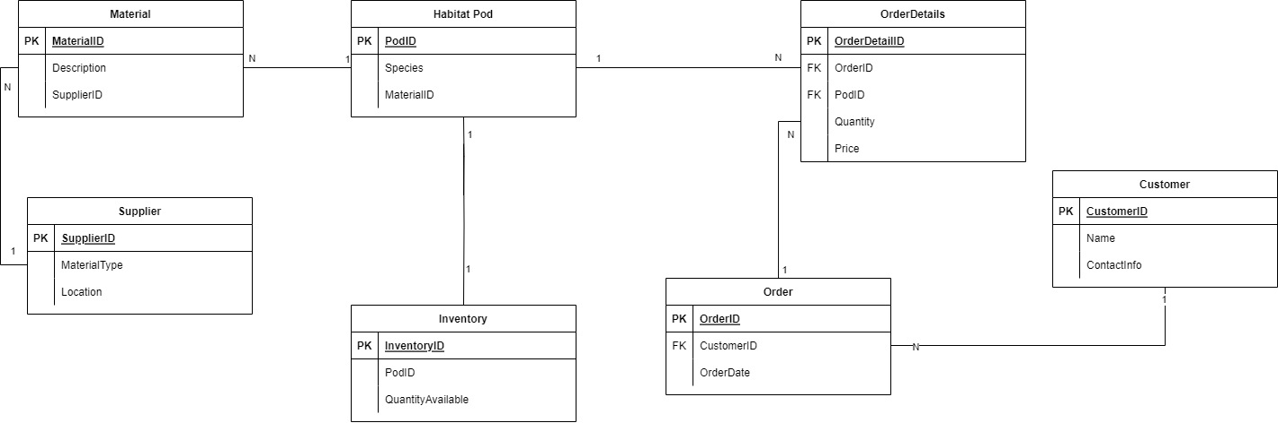

ERD using Crow’s Foot (**Logical Model**):

The addition of the **Material** and **OrderDetails** entities to the Entity-Relationship Diagram (ERD) offers several benefits to the database schema and the business logic of Eco-Domes. Here's a breakdown of these additions and the reasons for their inclusion:

**New Entity: Material**

Added to track the variety of construction materials used for Habitat Pods, associate them with respective suppliers for supply chain efficiency, and manage inventory specifics such as sustainability attributes, cost, and stock levels.

**Attributes:**

* **MaterialID**: A unique identifier for each material type.
* **Description**: A text description of the material.
* **SupplierID**: Connects to the **Supplier** entity as a Foreign Key.

**New Entity: OrderDetails**

Introduced to handle the complexity of orders containing multiple Habitat Pods, allowing for itemized tracking of quantities and prices, thus facilitating detailed sales analytics, inventory management, and customized billing.

**Attributes:**

* **OrderDetailID**: A unique identifier for each order line item.
* **OrderID**: Connects to the **Order** entity as a Foreign Key.
* **PodID**: Connects to the **Habitat Pod** entity as a Foreign Key.
* **Quantity**: The number of Habitat Pods of a particular type in an order.
* **Price**: The price per Habitat Pod, if needed.

**Description of the Relationships:**

1. **Habitat Pod to Material:** "Each Habitat Pod is constructed from 1 and only 1 type of Material, while a Material can be used for 0 or more Habitat Pods."
2. **Material to Supplier:** "Each Material is supplied by 1 and only 1 Supplier, whereas a Supplier can provide 1 or more types of Materials."
3. **Order to Customer:** "Each Order is placed by 1 and only 1 Customer, and a Customer can make 0 or more Orders."
4. **OrderDetails to Order:** "Each OrderDetail corresponds to 1 and only 1 Order, while an Order can consist of 1 or many OrderDetails."
5. **OrderDetails to Habitat Pod:** "Each OrderDetail relates to 1 and only 1 Habitat Pod, but a Habitat Pod can be associated with 0 or more OrderDetails (indicating that some Habitat Pods might not have been ordered yet)."